Activity handouts

The following pages contain handout sheets for the following small group activities:

Module IV: Activity 4.3, Scenarios 1-4
Module V: Activity 5.1, Scenarios 1-3

As the instructor, you may choose to copy or print these pages prior to the class and hand them out to the groups when conducting the activities.

The handouts may be printed in color or black and white, as resources allow.

Activity 4.3 Handout
Scenario 1
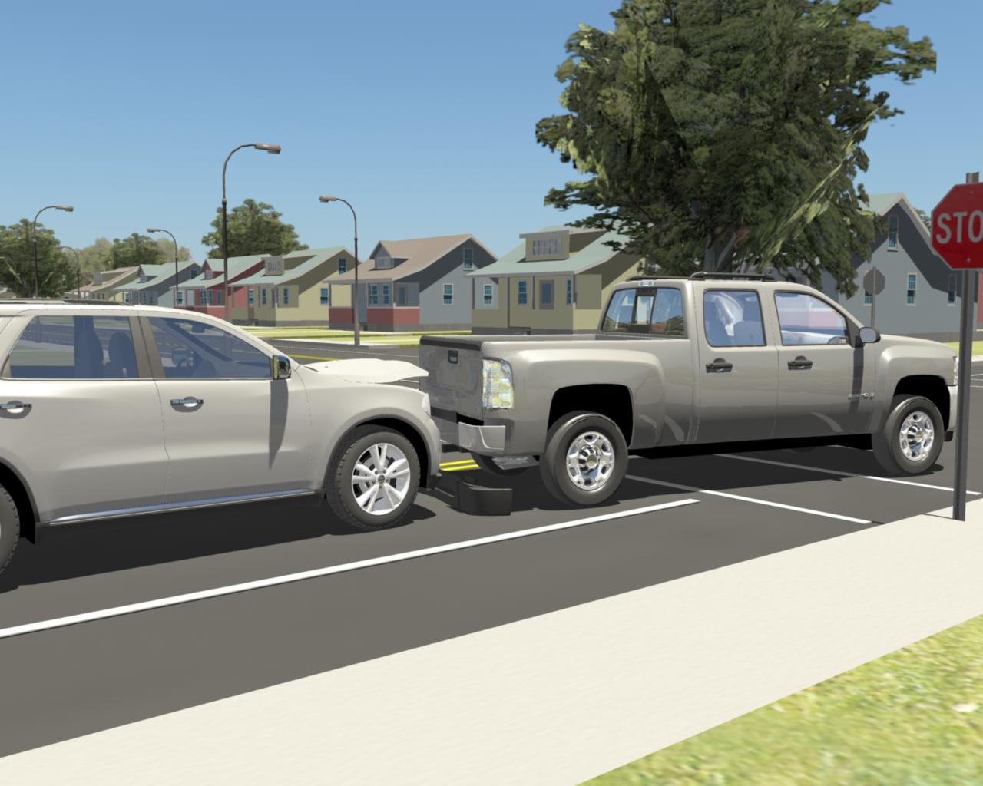
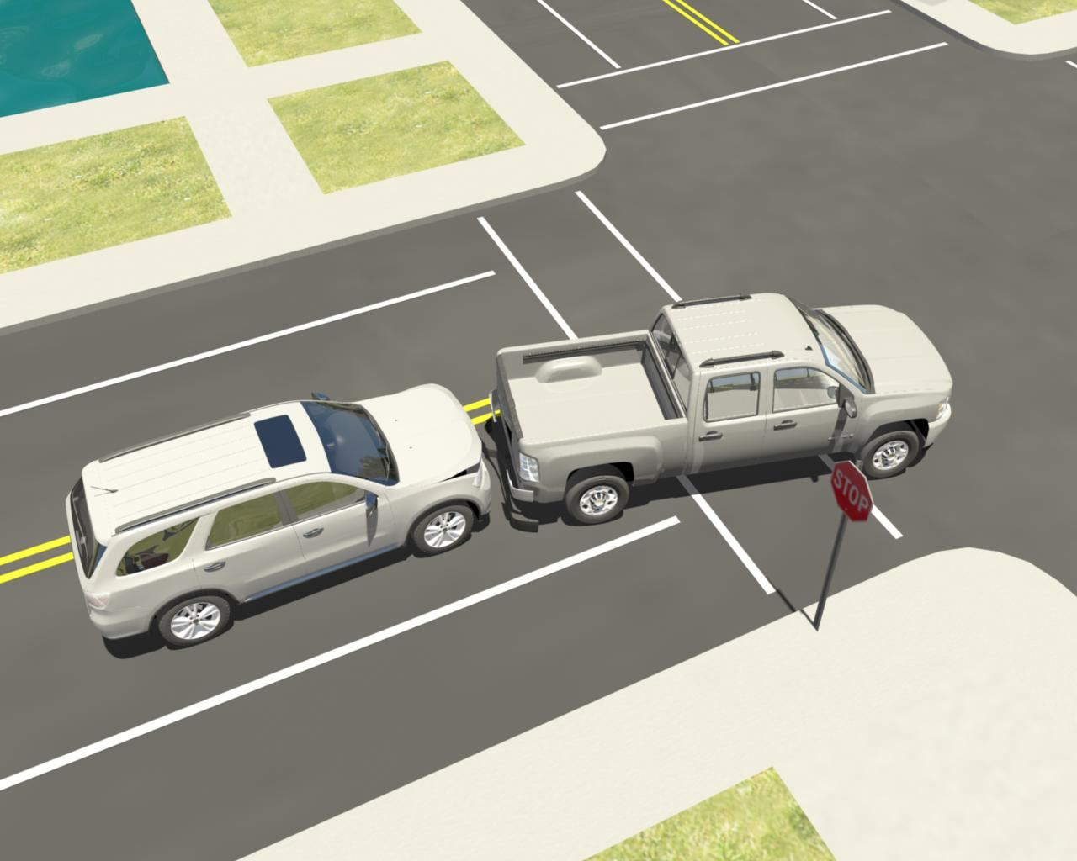

You are dispatched to a traffic crash at the A and 1st Streets. It is 5:30 pm. Temperature is 60°F, sunny and calm. On arrival you find two vehicles involved in a rear end collision. A GMC Yukon ran into the back of a pickup that was stopped at the red light. There is extensive damage to the front end of the Yukon. The badging on the Yukon indicates it is a HEV. There is a small amount of fuel leaking from the pickup and engine coolant is leaking from the Yukon. The airbags in both vehicles are deployed. The driver of the Yukon is still in the vehicle but appears to be conscious. The driver of the pickup is standing on the sidewalk.

Answer the questions listed below for your scenario. Use your EFG Classroom Edition (if available) to help determine disabling procedures.
- What hazards are present in this scenario?
- What are your scene safety priorities?
- What methods would you use to secure and disable this vehicle
- What vehicle-specific response concerns are indicated in the Emergency Field Guide?
Activity 4.3 Handout
Scenario 2

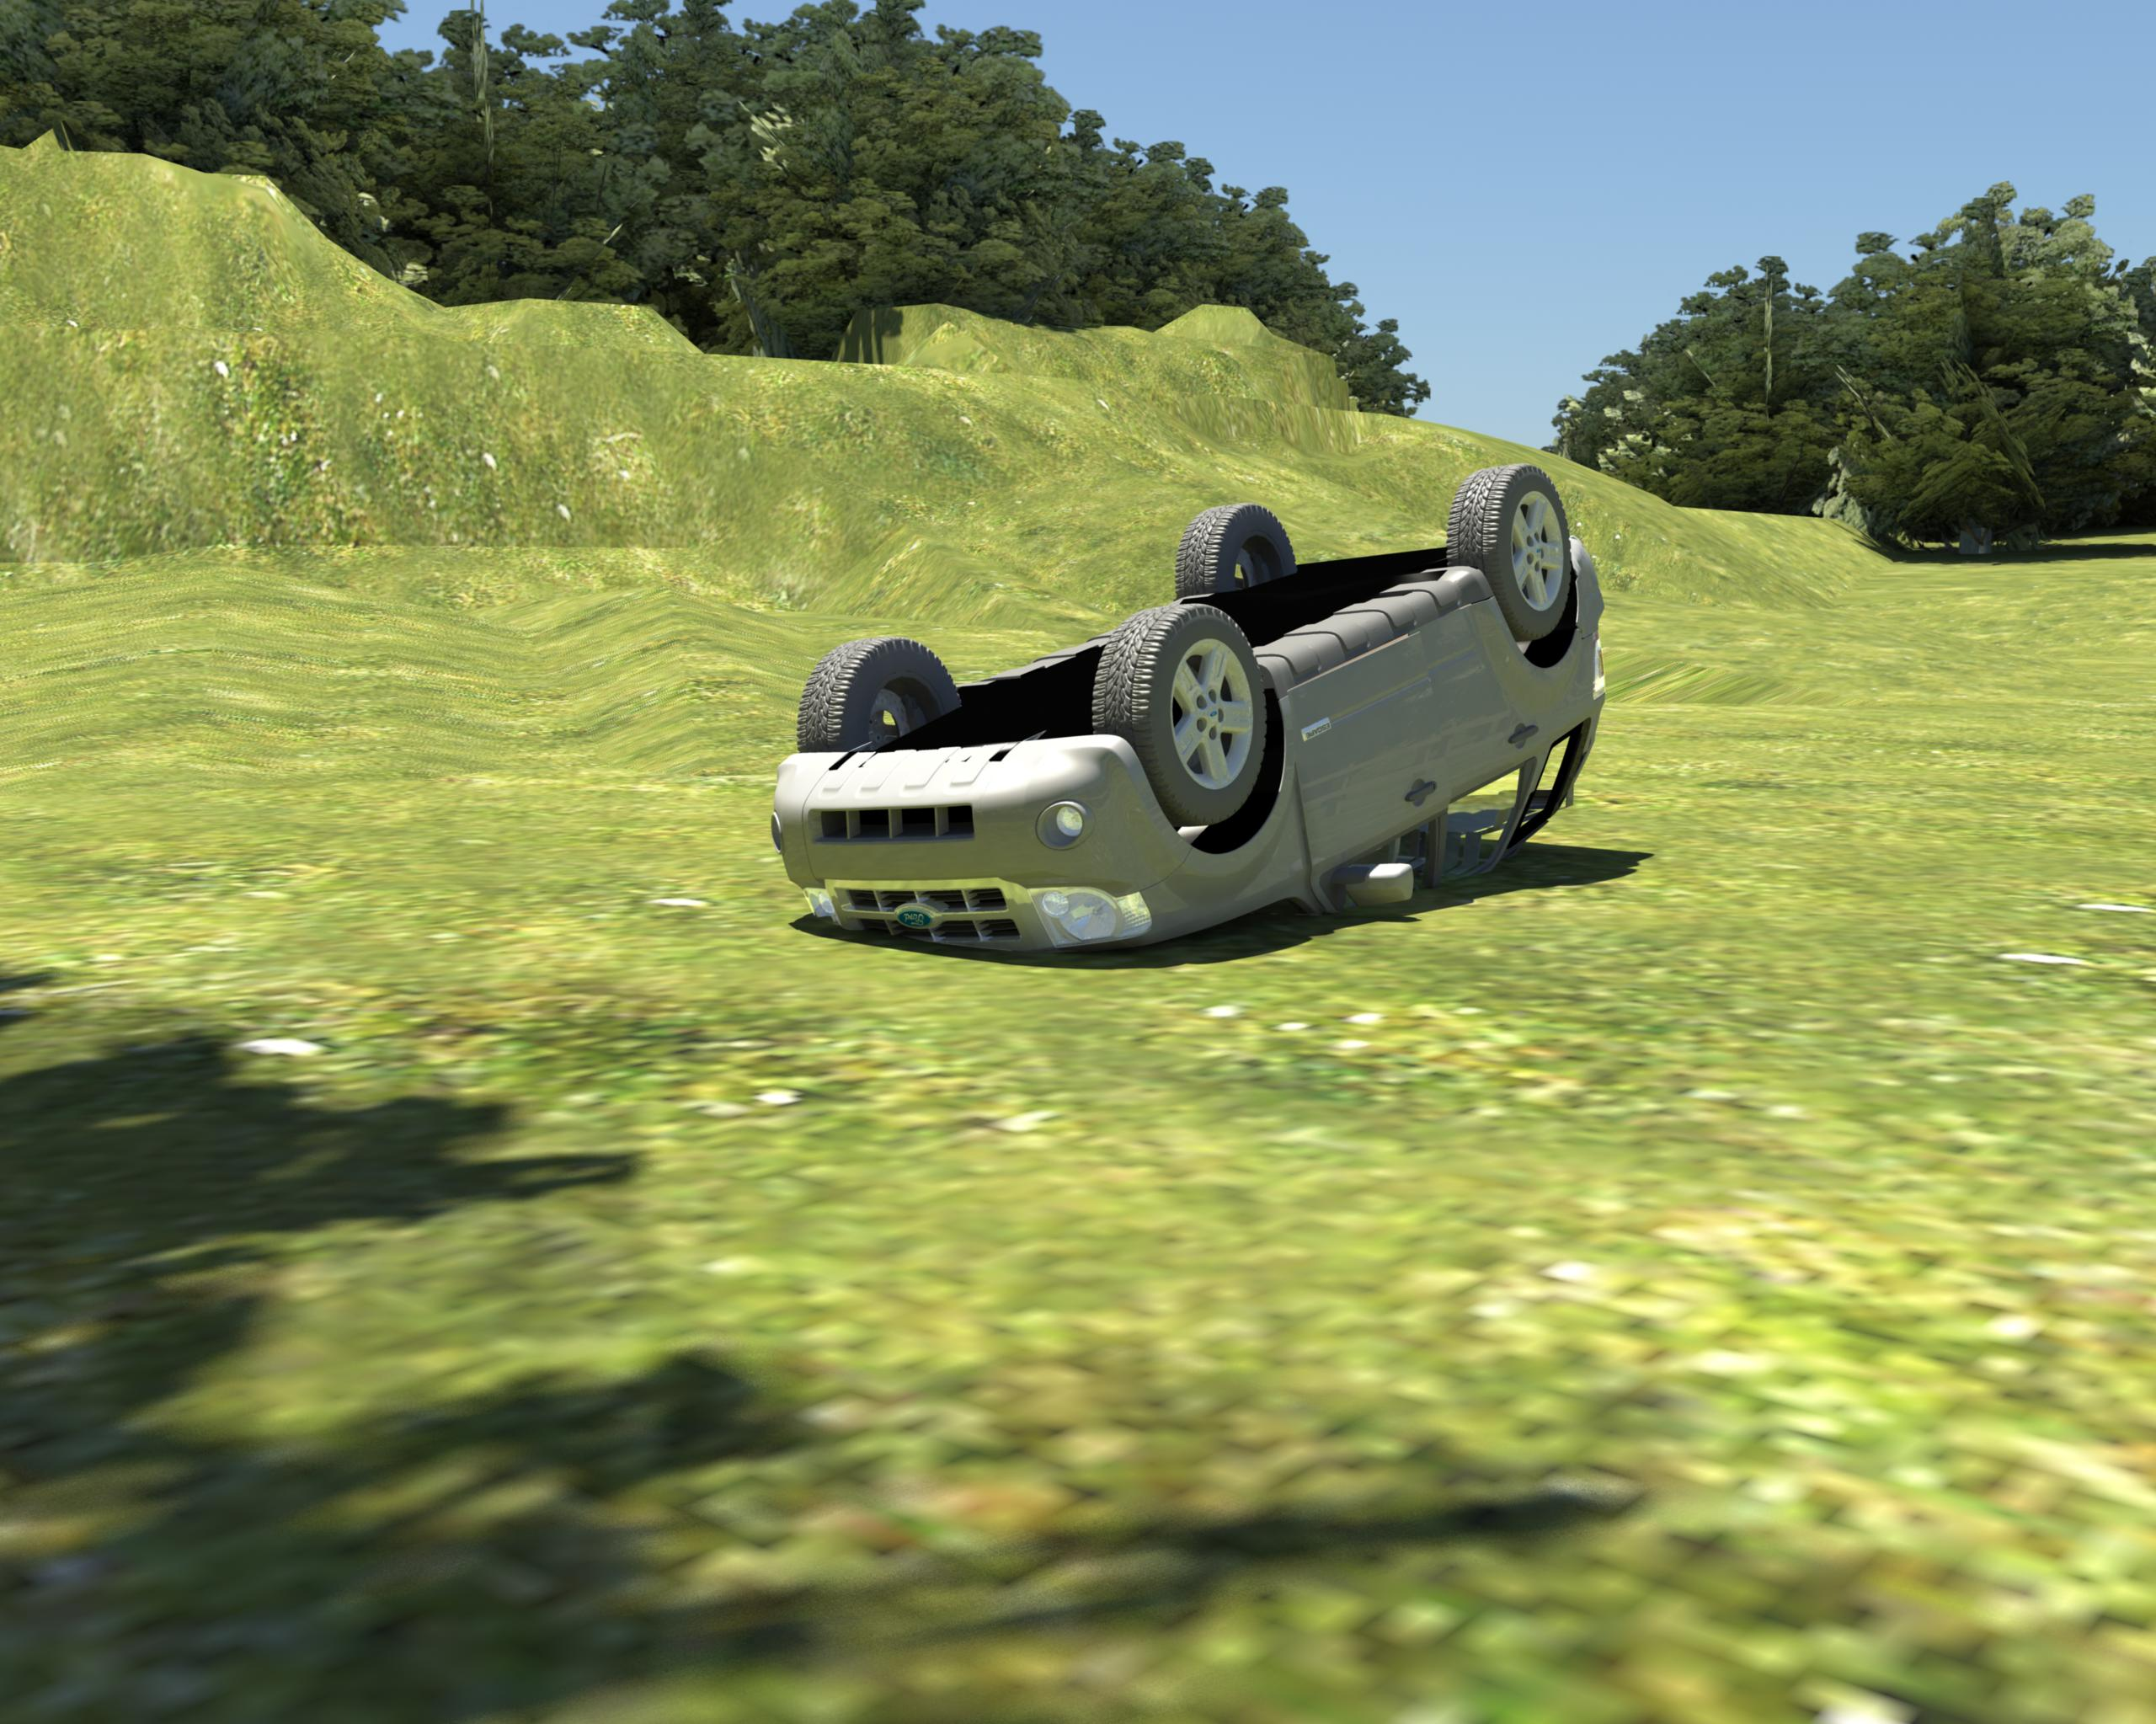
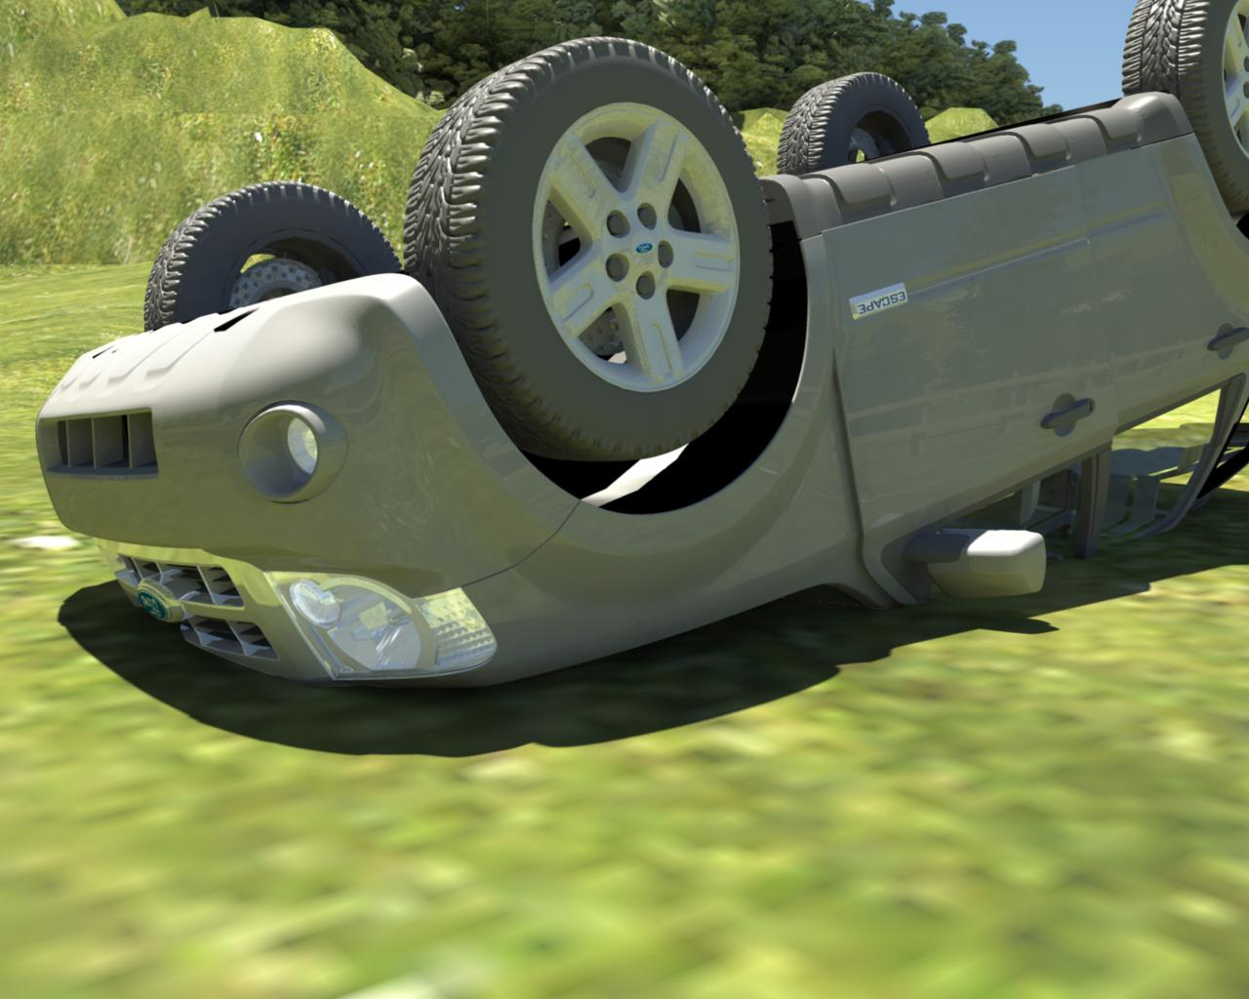

You are dispatched to a possible rollover on County Rd. 185. You know this section of road to be a gravel surface which periodically causes drivers to lose control of their vehicles. The reporting party states there are two people trapped in the vehicle. It is 2:00 pm, 18 °F, and calm. En route, the dispatch center informs you that the vehicle is a Ford Escape hybrid and the airbags have deployed. On arrival you find the vehicle in a field approximately 100 feet from the road, on its roof. It appears to have rolled end over end several times. The roof of the vehicle is collapsed approximately 2 feet. You observe two passengers in the vehicle. They are both conscious and talking to you. Both passengers are wearing their safety belts. There are two sheriff deputies on scene and they have the road blocked to traffic.

Answer the questions listed below for your scenario. Use your EFG Classroom Edition (if available) to help determine disabling procedures.
- What hazards are present in this scenario?
- What are your scene safety priorities?
- What methods would you use to secure and disable this vehicle
- What vehicle-specific response concerns are indicated in the Emergency Field Guide?

Activity 4.3 Handout
Scenario 3

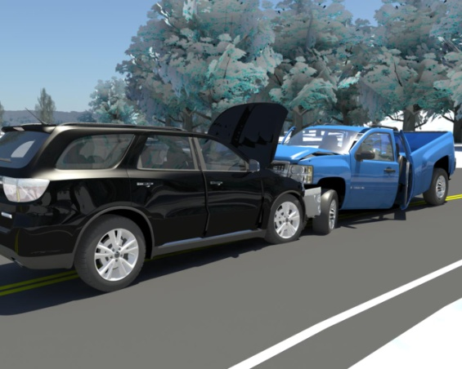

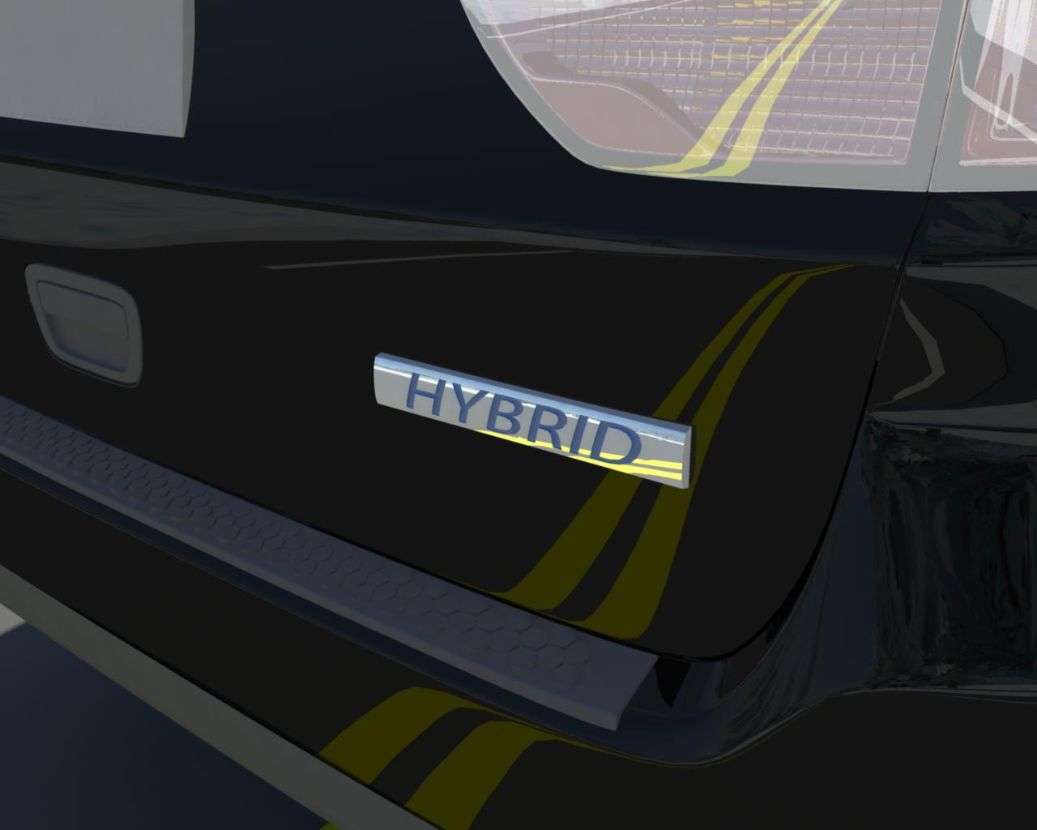

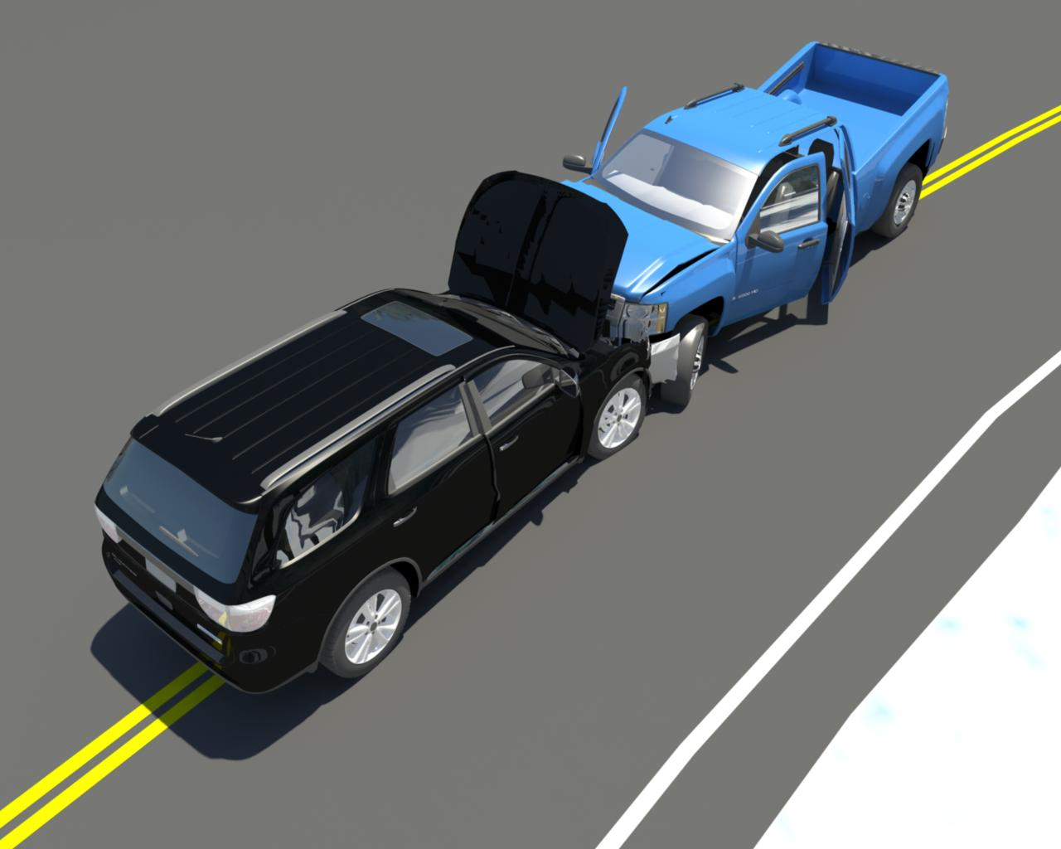

You are dispatched to a reported head-on collision on State Highway 12, approximately ½ mile east of downtown. It is 4 pm, 21 degrees and there is some freezing rain. The roads are ice-covered and very slick. There have been numerous crashes around the city in the last 2 hours. On arrival you find two late-model cars that ran head-on in an intersection. One or both apparently could not stop on the ice. Both are SUVs. One is a Dodge Durango that is badged as a hybrid. Passengers are still inside the Dodge Durango but do not appear to be injured. The body is damaged in the area in front of the doors, making it impossible to open the front doors. The passengers from the other vehicle are in a bystander’s car staying warm. There is glass and debris scattered around the vehicles. Due to the call volume, no police officers are available to provide traffic control. Both vehicles are leaking fluids from the engine compartments.

Answer the questions listed below for your scenario. Use your EFG Classroom Edition (if available) to help determine disabling procedures.
- What hazards are present in this scenario?
- What are your scene safety priorities?
- What methods would you use to secure and disable this vehicle
- What vehicle-specific response concerns are indicated in the Emergency Field Guide?
Activity 4.3 Handout
Scenario 4

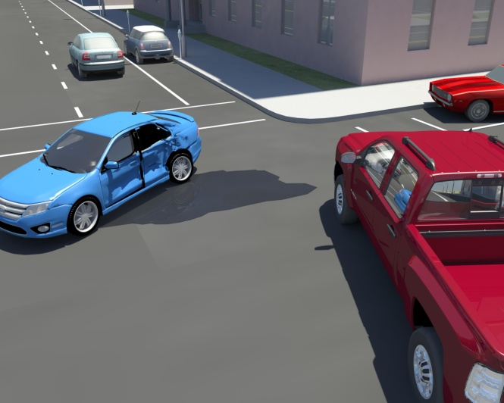

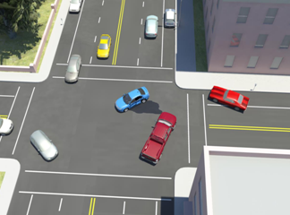

You are dispatched to a reported traffic crash at the intersection of Rolling Rock and Meadow Lane. It is 2:30 pm, 85°F, and there is a moderate wind. On arrival, you find a two-vehicle crash. It appears that one vehicle may have run a red light and struck the other vehicle in the passenger door. The vehicle that was struck in the door is a Ford Fusion that is badged as a hybrid. There is extensive damage to the Fusion and the driver appears to be unconscious. She is the only occupant of the vehicle. The airbags have deployed on both vehicles. There is a great deal of liquid under the Fusion which smells like gasoline. The occupants of the other vehicle appear to be conscious with only minor injuries. Traffic is still moving by the crash scene.

Answer the questions listed below for your scenario. Use your EFG Classroom Edition (if available) to help determine disabling procedures.
- What hazards are present in this scenario?
- What are your scene safety priorities?
- What methods would you use to secure and disable this vehicle
- What vehicle-specific response concerns are indicated in the Emergency Field Guide?
Activity 5.1 Handout
Scenario 1

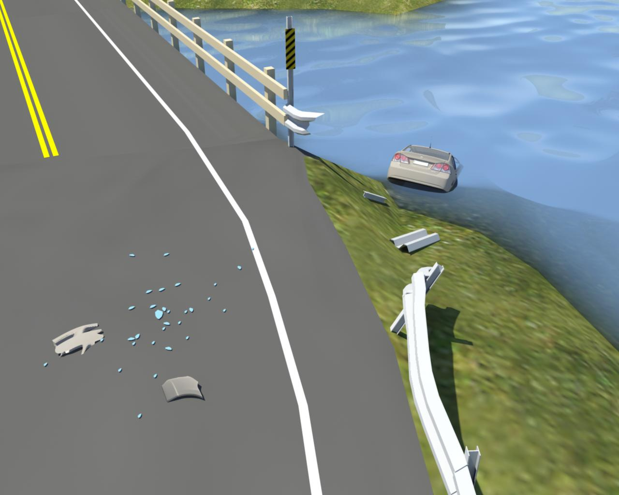
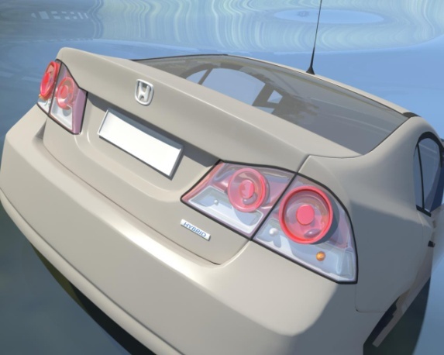
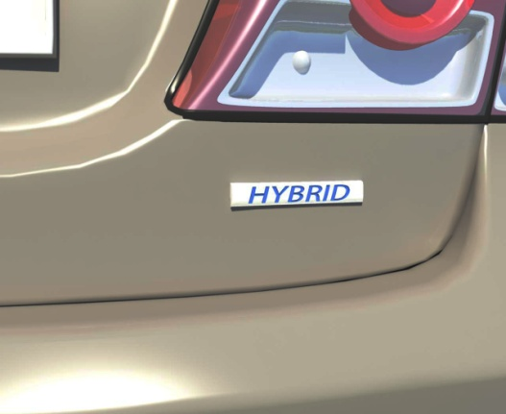

You are dispatched to a reported car in the canal. It is 3:00 p.m. on a Saturday, 91°F and sunny. The canal is very popular with boaters on the weekends. On arrival, you find a single Honda Civic hybrid, partially submerged in the canal. The vehicle has gone through the guard rail and stopped with the front half of the vehicle in the canal. There is no other damaged vehicle at the scene, but there are pieces of broken lenses and glass on the roadway, indicating a collision did occur. Bystanders state the driver is still in the car and appears to be unconscious. They also state that airbags have deployed.

Working in your assigned group, answer the following questions for each scenario when directed by the instructor.
- What pertinent information did you gather from a size up, i.e. what hazards are present?

- What action must be taken to ensure a safe work environment for this operation?

- In general, what action should be taken to mitigate the incident?

Be prepared to share your answers with the class.

Activity 5.1 Handout
Scenario 2
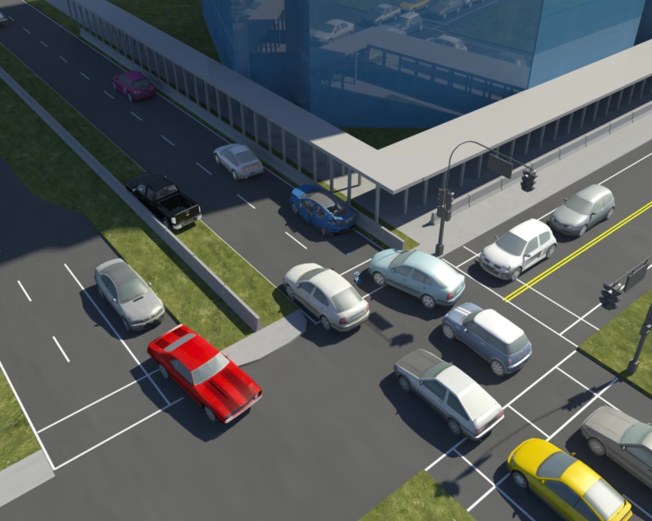
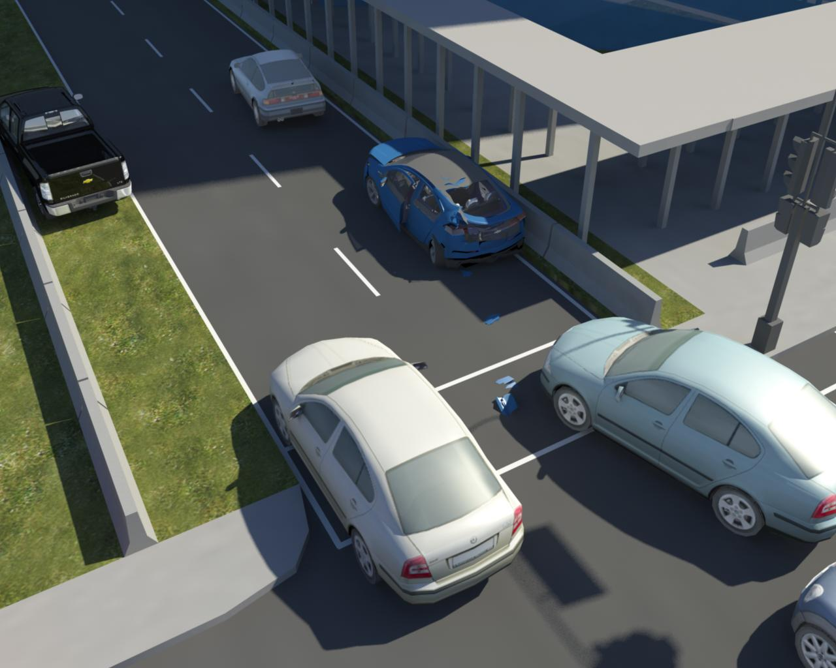
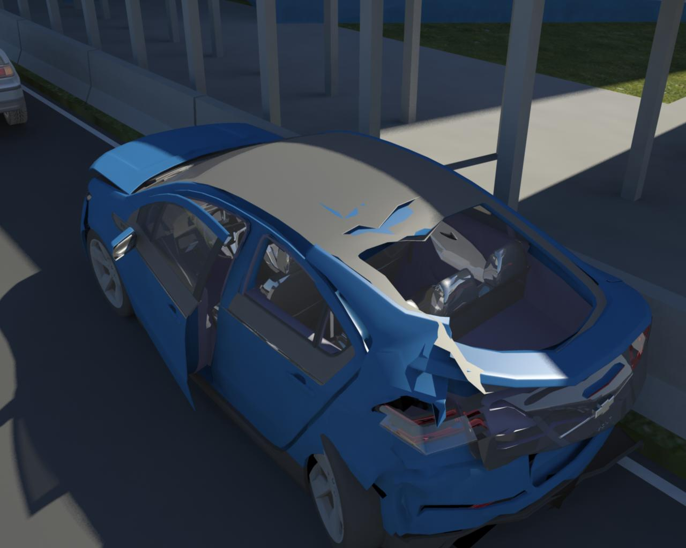

You are dispatched to a reported motor vehicle crash. The reporting party stated that he rear-ended a car stopped at a stoplight. It is Friday at 5:15 pm. It is 78°F and sunny. The location of the incident is on a four lane highway that has a high volume of commuter traffic. En route, dispatch reports that OnStar called and one of the vehicles involved in the crash is a Volt and that airbags have deployed. On arrival, you find one vehicle (a 4-door sedan) against the inside guardrail with severe damage to the rear of the vehicle. The other vehicle (a minivan) is against the outside guardrail. Both vehicles are oriented in the direction of travel. There are at least two passengers in the sedan and at least one passenger in the minivan.

Working in your assigned group, answer the following questions for each scenario when directed by the instructor.
- What pertinent information did you gather from a size up, i.e. what hazards are present?

- What action must be taken to ensure a safe work environment for this operation?

- In general, what action should be taken to mitigate the incident?

Be prepared to share your answers with the class.
Activity 5.1 Handout
Scenario 3

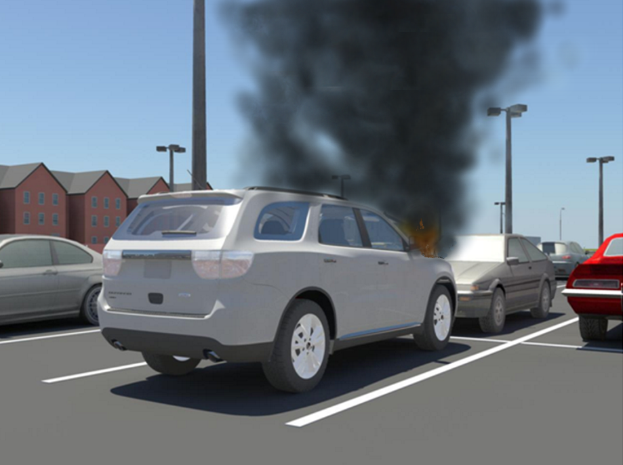
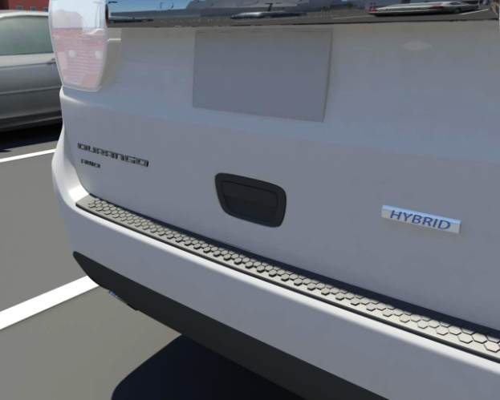
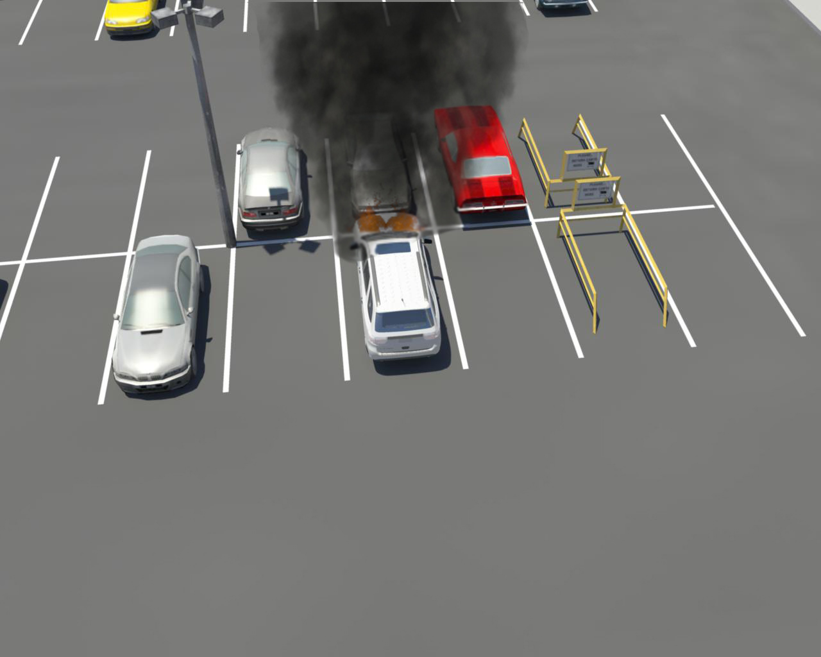

You are dispatched to a reported vehicle fire in the parking lot of a local shopping mall. As you approach the parking lot you see a small column of smoke coming from a group of cars parked close to an entrance. It is Saturday at 11 am, 75°F, there is a mild breeze. On arrival, you find a hybrid Highlander SUV with smoke and flames coming from the engine compartment area and heavy smoke coming from the passenger compartment through the driver window. The parking spaces on both side of the vehicle are empty; however, the spaces immediately in front of the vehicle are filled. The owner meets you and tells you that no one is in vehicle.

Working in your assigned group, answer the following questions for each scenario when directed by the instructor.
- What pertinent information did you gather from a size up, i.e. what hazards are present?

- What action must be taken to ensure a safe work environment for this operation?

- In general, what action should be taken to mitigate the incident?

Be prepared to share your answers with the class.

